Obituaries

Bishop Antonio Riboldi

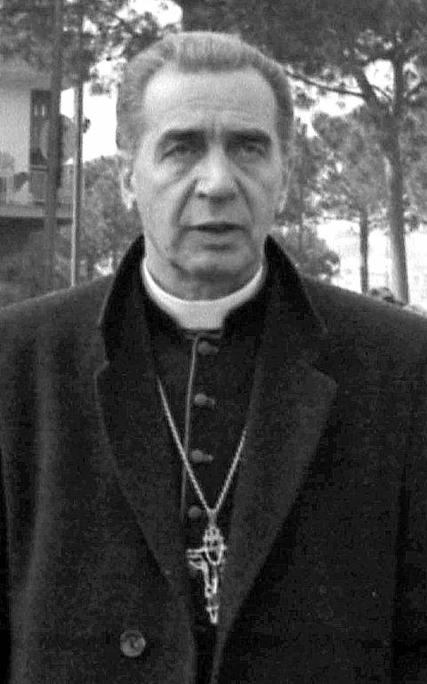
Roman Catholic churchman who stood up to the Mafia
BISHOP ANTONIO RIBOLDI, who has died aged 94, was one of the Roman Catholic Church’s leading opponents of the Sicilian Mafia and the Neapolitan Camorra.
Antonio Riboldi was born into a poor family at Tregasio, a village outside Milan, on January 16 1923. As a young man he joined the Institute of Charity, a religious order, also known as the Rosminians, founded in the 19th century by the church reformer Father Antonio Rosmini.
In Turin, on May 21 1944, with nine other novices, Riboldi was rounded up by German troops who threatened to shoot them, but after lengthy discussions with the Germans, their religious superior obtained their release.
Ordained in 1951, Riboldi, who was deeply influenced by a Rosminian, Clemente Rebora, one of Italy’s leading poets, looked forward to an academic career, but instead, in 1958, he was sent to the parish of Santa Ninfa in the Belice valley behind the Sicilian capital, Palermo. In 1968 the valley was struck by an earthquake which killed 300 people. It had always been a Mafia-infested zone but the organisation became even more powerful by profiting from the aid provided after the quake.
Riboldi, who had to live in a prefabricated house like the other survivors, became their spokesman in deploring both the deficiencies of the aid programme and the Mafia’s influence. He was a trailblazer in a Church not used to tackling the Mafia head-on, but found allies in figures such as Piersanti Mattarella, the President of the regional government of Sicily, and General Alberto Dalla Chiesa of the carabinieri, who had been appointed by the government to fight the Sicilian Mafia.
After waiting seven years for decent post-quake housing, Riboldi took a group of Belice children to Rome to protest before Parliament and the presidential palace about the inadequate aid, as a result of which more help was forthcoming.
Although some Catholics were critical of Riboldi, Pope Paul VI was not, and in 1978 made him Bishop of Acerra on the outskirts of Naples. Within a few years Mattarella and Dalla Chiesa, both Riboldi’s allies in Sicily, were assassinated by the Mafia.
Acerra, a community of 30,000, had not had a bishop for 12 years and was oppressed by the Camorra, the Neapolitan crime syndicate.
But Riboldi was determined to stand up to organised crime and called on Camorra members to repent. As a result, a local leader, who was in hiding, sought him out. Riboldi talked with him for three hours, running the risk of being arrested for not notifying the police, and eventually commanded him, in the name of God, to repent. He did so but, because of this, was later assassinated, after which Riboldi was given a police escort.
Undeterred, Riboldi organised protest marches and entered into negotiations with a group of Camorra members, with the intention of convincing them to hand over their arms to him. But it came to nothing. He did, however, convince some to repent, but because of this he faced accusations of complicity.
Strongly built, with a sympathetic face and a cordial manner, Riboldi was a formidable communicator. He was one of the first bishops to put his homilies on the internet and published 10 books.
“In public lavatories,” he once said, “there are big towels. I’d like to be a big towel on which the poor, sinners, prisoners, and prostitutes clean their faces. When I no longer serve as a towel, I will be thrown away – and gathered, finally, by God.”
After retiring as bishop he remained in Acerra as a simple priest. In 2017, because of declining health, he returned to the Rosminian headquarters at Stresa, Piedmont, where he died.
Bishop Antonio Riboldi, born January 16 1923, died December 10 2017
Enjoy quality journalism, opinion and expertise from The Telegraph.
Try a 30-day FREE trial to the website or app.

